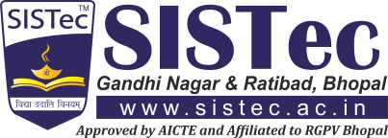Suraj Dhakad

## B.Tech. – Computer Science & Engineering

+91 **7440381220**

[surajdhakad034@gmail.com](mailto:surajdhakad034@gmail.com)

Morena, Madhya Pradesh, India – 466228

# Career Objective

To secure a position in an organization where I can efficiently contribute and polish my skills and abilities for the growth of the organization and build my professional career.

# Education

## Sagar Group of Institutions – SISTec Ratibad Campus, Bhopal - MP

B.Tech. – Computer Science & Engineering | CGPA: 7.16 / 10 (2020-2024)

## Hariom H.S. School, jagana ka pura no.2 Gwalior-MP

12th | MP Board | 60.5 % (2020)

## Mother Teressa High School, Anand Nagar, Gwalior- MP

10th | MP Board | 65.6 % (2018)

# Project Details

**Title**: Application for AICTE **Key Skills**: Flutter

**Description**: We have decided to build a Unique app with some additional features of adding message bot, institution names will be in alphabetical order. This app will be user friendly

# Key Technical Skills

**\*** Flutter **\*** C **\*** C++ * OOPS *Python * DBMS *PHP

# Workshops | Certifications

* Completed 14-days workshop on Machine Learning with Flutter Application at SISTec-R, Bhopal
* Completed an certified course on C \C++ programming from Excel Academy
* Completed an certified course on python for machine learning from great learning

# Co-Curricular Activities | Accolades

* Participated in Student of the year.

# Interpersonal Skills

* Adaptive **\*** Quick Learner

# Hobbies | Areas of Interest

* Playing Cricket **\*** Playing Video game

# Personal Details

Date of Birth :15/09/2001

Father’s Name : Mr. Harisingh dhakad

LinkedIn :<https://www.linkedin.com/in/suraj-dhakad-20a246236/>